TASK 1
Data Science Fundamentals Assessment
Python basics, data types, statistics and good working habits
Data Science Internship Report
Submitted by: [Your Full Name]
November 2026

1. Introduction
This report covers the foundations I worked through for the fundamentals assessment: Python basics, the kinds of data a data scientist deals with, the statistics that sit underneath almost every analysis, and the working habits that stop a project from turning into a mess. I did not want to just copy definitions, so every concept below is paired with something I actually ran. Where I needed real data I used the public "tips" dataset (244 restaurant bills, from the seaborn-data repository), because it is small enough to reason about by hand and still messy enough to be interesting.
The code for everything in this report is in the accompanying GitHub repository (scripts/task1_fundamentals.py), so each number can be reproduced.

2. Python basics

2.1 Core data types
Almost everything in data work starts from a handful of built-in types. The ones I used most were integers, floats, strings and booleans for single values, and lists, tuples, dictionaries and sets for collections. Checking each with type() confirmed what I expected:
Type | Example | Mutable? | Where I use it
int | 42 | No | Counts, IDs, party size
float | 3.14 | No | Prices, measurements
str | "Dinner" | No | Labels, categories
bool | True | No | Filters and flags
list | [1, 2, 3] | Yes | Ordered collections of rows or values
tuple | (1, 2) | No | Fixed pairs such as (rows, columns)
dict | {"a": 1} | Yes | Lookups, JSON-like records
set | {1, 2} | Yes | Unique values, fast membership tests

2.2 A floating point surprise
One thing that surprises many beginners: in Python, 0.1 + 0.2 gives 0.30000000000000004, and 0.1 + 0.2 == 0.3 is False. This is not a Python bug. Computers store decimals in binary, and some simple decimals cannot be represented exactly. The practical fix is to compare floats with a tolerance (numpy.isclose returned True for the same comparison) rather than with ==. It matters in data science because totals, averages and prices are all floats.

2.3 Control flow, functions and comprehensions
I practised the usual building blocks: if/elif/else for decisions, for and while loops for repetition, and functions to avoid copying code. List comprehensions turned out to be the most useful Python-specific idea. For example, this one line labels every bill as large or small:
def size_label(bill, cutoff=30):
return "large" if bill > cutoff else "small"

labels = [size_label(x) for x in tips["total_bill"]]
Writing small functions with clear names also made it far easier to test pieces separately, which I come back to in the best-practices section.

3. Data types in data science
Python types are only half of the story. For analysis, what matters is what the variable means, because that decides which summaries and charts make sense.
- Numerical, continuous (e.g. total_bill, tip): can take any value in a range. Means, standard deviations and histograms all make sense.
- Numerical, discrete (e.g. size, party size): whole-number counts.
- Categorical, nominal (e.g. sex, smoker): labels with no order. Averaging them is meaningless; counts and proportions are the right summaries.
- Categorical, ordinal (e.g. day, or a rating from 1 to 5): labels with a natural order, but gaps between values are not necessarily equal.
- Time and text data: dates need to be parsed into proper datetime types before you can sort, group by month or compute durations.
In pandas this shows up as dtypes. After loading the tips file, total_bill and tip came in as float64, size as int64, and the four categorical columns as text. Converting text columns with only a few distinct values to the category dtype saves memory and prevents silly mistakes. I also learned to check df.dtypes straight after loading, because a numeric column read in as text (usually because of a stray symbol) quietly breaks everything downstream.

4. Statistical foundations

4.1 Descriptive statistics
I started by summarising the total bill. The results for all 244 bills:
Measure | Value | What it tells me
Mean | $19.79 | The "balance point" of the data
Median | $17.8 | The middle bill; half are lower, half higher
Mode | $13.42 | The most frequent value
Standard deviation | $8.9 | Typical distance of a bill from the mean
Q1 / Q3 | $13.35 / $24.13 | Middle 50% of bills sits in this range
IQR | $10.78 | Spread that is not affected by extreme bills
Min / Max | $3.07 / $50.81 | The full range
Skewness | 1.13 | Positive means a long tail to the right

The mean ($19.79) sits above the median ($17.8), and the skewness is 1.13. Together these say a few expensive bills are dragging the average up. This is why I now report the median alongside the mean whenever data is skewed, since the median describes a "typical" bill more honestly.
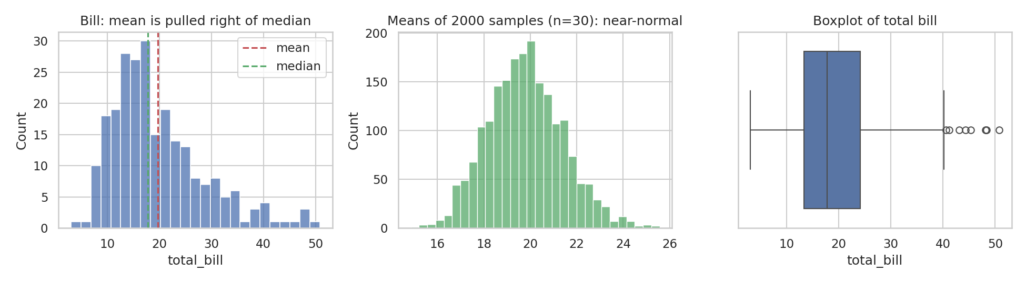
Figure 1. Left: bill distribution with mean and median. Middle: distribution of sample means. Right: boxplot.

4.2 Sampling and the Central Limit Theorem
The bill data is clearly not bell-shaped (skewness 1.13). To see the Central Limit Theorem for myself, I drew 2,000 random samples of 30 bills each and recorded the mean of every sample. The average of those means came out at $19.79, essentially the true mean of $19.79, and their skewness dropped to 0.24, so the distribution of sample means is close to symmetric even though the underlying data is not. The theoretical standard error is s/√n = $1.63; the observed spread of my simulated means was $1.61. Seeing those two numbers agree made the theory feel real in a way the textbook formula had not.

4.3 Confidence intervals and a hypothesis test
Using the t-distribution, the 95% confidence interval for the mean bill is $18.66 to $20.91. The interval describes our uncertainty about the population mean; it does not mean 95% of bills fall inside it,.
I then asked a simple question: do dinner bills differ from lunch bills? Dinner averaged $20.8 and lunch $17.17. A Welch two-sample t-test gave t = 3.12 and p = 0.0022. With the usual 0.05 threshold, that is evidence of a real difference. The caveat I wrote down for myself: this is observational data from a single restaurant, so it says dinner bills are higher here, not why.

4.4 Correlation
Bill and tip have a Pearson correlation of 0.676 and a Spearman correlation of 0.679. They agree closely, which suggests the relationship is roughly linear and not driven by a handful of outliers. A strong correlation still does not prove that a bigger bill causes a bigger tip: both are driven by how many people were at the table.

4.5 Probability intuition
As a quick sanity check on the idea of long-run frequency, I simulated 10,000 coin flips. The proportion of heads was 0.4968, close to 0.5 but not exactly, which is what randomness should look like.

5. Industry best practices I am following
- Reproducibility. Set random seeds, record library versions and keep code in scripts or notebooks that run top to bottom.
- Version control. Commit small, meaningful changes to Git with readable messages so mistakes can be undone.
- Look before you model. Check shape, types, missing values and duplicates first. Most bad results I have seen come from skipping this.
- Avoid data leakage. Split into train and test sets before any step that learns from the data, such as scaling or imputing.
- Document assumptions. Write down why a value was dropped or filled in, so someone else (or future me) can challenge the choice.
- Communicate honestly. Report uncertainty, mention limitations, and choose charts that do not exaggerate differences.
- Ethics and privacy. Be careful with personal data, and think about whether a dataset represents the people a decision will affect.

6. What I learned
The biggest shift for me was moving from "calculate the number" to "ask whether the number can be trusted". Knowing the formula for a mean is easy; noticing that the mean is misleading for a skewed distribution is the actual skill. I also found that running small experiments, such as the Central Limit Theorem simulation, made abstract ideas stick far better than reading about them. Next, I want to get more comfortable with choosing the right statistical test for a given question and with explaining results to people who do not have a statistics background.

7. Conclusion
This assessment gave me a working foundation in Python, in the types of data I will meet, and in the core statistical ideas behind later tasks. Each concept is demonstrated in code and reproducible from the GitHub repository, which the later tasks (the lab setup, the dataset analysis, the reporting task and the capstone) build on directly.

